|  |  |
| --- | --- |
| Roll No.: A016 | Name: Varun Khadayate |
| Class: B. Tech CsBs | Batch: 1 |
| Date of Experiment: 18-09-2022 | Subject: ITWS |

Lab 6: M-script file

* 1. Create a file called mysphere.mat
  2. Create and plot a sphere using sphere function. Sphere function creates a unit circle which can be scaled using surf function (hint: try different values of ‘r’ using surf function).
  3. Run and observe the output
  4. What is your observation?

|  |
| --- |
| While running the code with different value of r there are different sphere, and we can see that the dimension also changes. Below is the screenshot of 3 sphere in one graph  [x y z] = sphere;  a=[3 3 3 3;-3 -3 -3 3;0 4 -2 2];  s1=surf(x*a(1,4)+a(1,1),y*a(1,4)+a(1,2),z*a(1,4)+a(1,3));  hold on  s2=surf(x*a(2,4)+a(2,1),y*a(2,4)+a(2,2),z*a(2,4)+a(2,3));  s3=surf(x*a(3,4)+a(3,1),y*a(3,4)+a(3,2),z*a(3,4)+a(3,3));  daspect([1 1 1])  view(30,10) |

1. 1. Create an excel sheet consisting the following data :

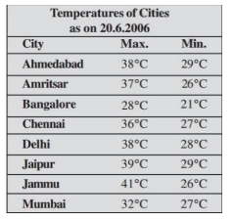

* 1. Explore xlsread function using help
  2. Read the excel file created in step a) using xlsread function
  3. d) Create an M-File and write a script which finds the following:
     1. Compare and identify the city that recorded the max temperature
     2. Plot the given data using bar graph

|  |
| --- |
|  |